**Nigeria Security Welcome Pack**

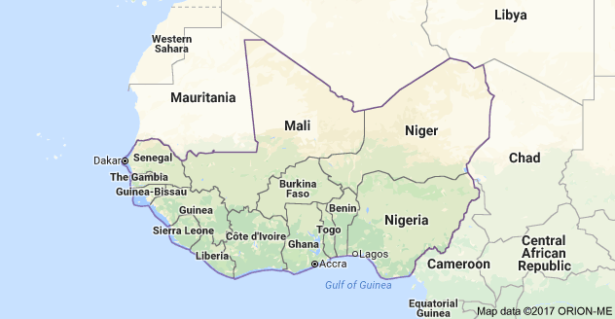

|  |  |
| --- | --- |
| **Reviewed** | **JUNE , 2018** |
| **Updated** | **DECEMBER, 2018** |

**TABLE OF CONTENTS**

Cover page-----------------------------------------------------------------------1

Table of Contents--------------------------------------------------------------2

1. Introduction-----------------------------------------------------------------------3
2. Country Summary---------------------------------------------------------------5
3. Entry Requirements-------------------------------------------------------------8
4. Accommodation -----------------------------------------------------------------10
5. Safety and Security--------------------------------------------------------------11
6. Nice to Know----------------------------------------------------------------------13
7. Key Contacts----------------------------------------------------------------------14

**1.0 INTRODUCTION**

WaterAid Nigeria is often hosting international visitors from member offices, donors and supporters.

The aim of the Welcome Pack is to inform short-term visitors of useful information that is important for their visit. It is updated regularly to reflect current security situation in Nigeria, and will also provide some useful information that visitors should know before starting their journey.

The document serves as a Pre-departure brief and will be supplemented by a verbal security briefing upon arrival to Nigeria.

1:Pictures of important sites and monuments within the country

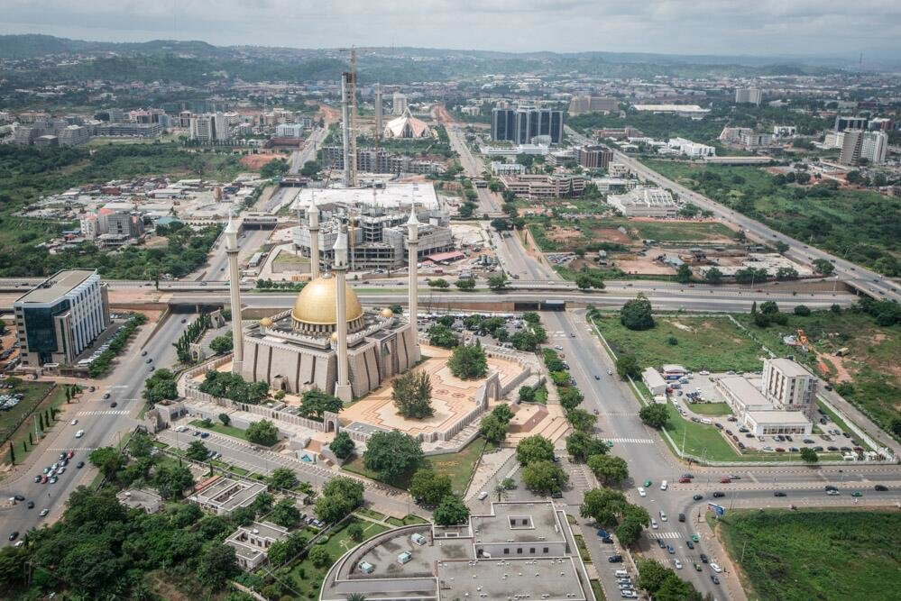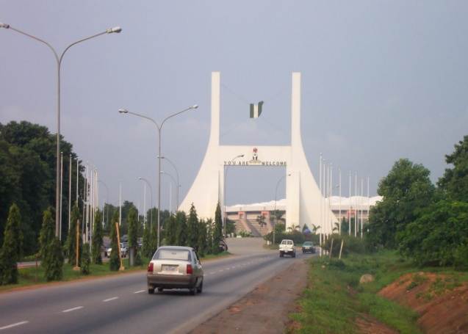

Abuja city Gate Aerial View of Abuja

[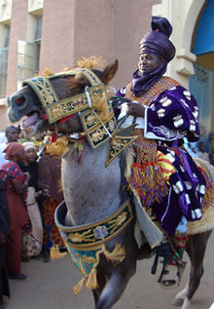](http://en.wikipedia.org/wiki/File:Durbar.jpg)

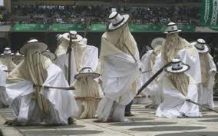

A horseman at the Durbar Eyo Festival

**SECURITY WELCOME PACK**

**2.1 Country Summary**

Nigeria is the most populous country in West Africa with a total population of about 165 million people translating into about 250 ethnic groups. Nigeria occupies a total area of 923,768 sq. km. There are **36** States in Nigeria, bound together by a Federal agreement. The Federal Capital Territory (FCT) is not a state and under the direct control of the Federal Government. The States are further divided into a total of **774** Local Government Areas.

Nigeria shares land borders with the Republic of Benin in the west, Chad and Cameroon in the east, and Niger in the north. Its coast lies on the Gulf of Guinea in the south and it borders Lake Chad to the northeast

The international Time Zone is GMT +1. Average life expectancy is about 54 years of age.

Nigeria gained her independence from British rule on October 1st 1960 and three years later became a Republic. Nigeria returned to democratic rule in 1999 after almost 33 years of military rule and the current government, headed by President Mohamadu Buhari was sworn in on May 29, 2015.

Religiously, Nigeria has 50% population as Muslims, 40% Christians and 10% indigenous beliefs. English is the official language however, Hausa, Yoruba, Ibo, Fulani and over 500 indigenous languages are spoken.

The most influential and politically influential tribes among the 250 ethnic groups are: Hausa and Fulani- 29%, Yoruba 21%, Igbo 18%, Ijaw 10%, Ibibio 3.5% and Tiv 2.5%.

The literacy level in the Country (age 15 and over who can read and write) is distributed as follows: 59.6% of the population can read and write; Male 69.2% and Female 49.7%.

Nigeria is rich in art and literature. Its Nok terracotta’s are the oldest in Sub-Saharan Africa and some of West Africa’s more elaborate and colourful festivals take place in Nigeria. One of such festivals held in Northern Nigeria, called the **“Durbar”**, takes place in Kano city (often quoted as the oldest city in West Africa). The event usually takes place sixty-nine days after the end of Ramadan. The durbar is a very colourful cavalry procession of ornately dressed men on royally decorated horses escorting the Emir of Kano, followed by flute players wearing feathered head-dresses.

The **“Eyo”** festival, also known as the “Adamu Orisha Play”, in western Nigeria takes place in Lagos State. The word “**Eyo**” refers to the costumed dancers known as the “masquerades” that come out during the festival. The origins of this observance are found in the inner workings of the secret societies of Lagos.

In eastern Nigeria, one of the popular festivals is the **“Iriji-Mmanwu”** festival usually held in Enugu state. The festival features a lively display of over 2,000 masquerades. The unique shapes, sizes and colourful attires of the masquerades as well as their rhythmic dances and acrobatic displays, make the festival an astounding and memorable even

*2.2.* **WaterAid Nigeria Focal States**

WaterAid has worked in Nigeria since 1996 and partners with the Government and people of Nigeria to develop sustainable access to Water, Sanitation and Hygiene.

WaterAid Nigeria currently has programme presence in : Bauchi, Enugu Kebbi and Plateau States. Zamfara State programme is yet to take off at the time of finalising on this welcome pack.

Zamfara

Kebbi

Bauchi

Abuja

Plateau

Enugu

|  |  |
| --- | --- |
|  | WANG Focal States |
|  | Programme presence yet to commence |

*2.3* **Cultural Practices, Norms, Sensitivities and Customs***.*

Nigeria is a Country with over 250 ethnic tribes speaking over 521 languages. The Hausa, Yoruba and Ibos are the largest and most dominant tribes; there are also other smaller ones. As the tribes differ so are their norms, sensitivities and customs. What is acceptable in one might be an abomination in another. The Northern part of the Country is predominantly Muslims while the Middle belt region down to the Southern part of the Country is predominantly Christians. A typical Muslim environment is different in every ramification from a Christian environment.

In the North it is advisable not to dress scantily. Women wear cloths which cover their body. It is not allowed for men to hold the opposite sex hands on the street or playing expensive love play on the streets. You must avoid public display of affection. At meetings women are separated from men. During greetings a man is not permitted to shake a woman’s hand.

From the Middle belt down South, most of the restriction in the north are not tenable. Abuja Nigeria capital city is devoid of such cultural sensitivities. You will therefore not offend anyone culturally while in Abuja.

*2.4* **Weather/Climate Conditions***.*

Nigeria is a Country on the north western land mass of the continent of Africa. It is close to the equator so falls entirely in the tropics. It is affected by the Atlantic Ocean weather patterns, although it has a south facing coastline. It borders Lake Chad to the northeast, also affecting weather for the region. There are two rivers that feed into the ocean, converging in the center of the country then heading south, sort of dissecting Nigeria in a ‘Y’ shape. As this waterway grows strength on its journey, it widens out to form one the greatest river deltas in the world.

Nigeria's location in the tropics has given her a tropical hot climate. Temperatures in Nigeria vary according to the seasons of the year as with other lands found in the tropics.Nigeria’s seasons are determined by rainfall with rainy season and dry season being the major seasons in Nigeria. The dry season, which lasts from October until April is determined by high temperatures and low humidity, and is affected by warm winds coming from the Sahara Desert to the north. These winds are known locally as ‘harmattan’, and they come into force around December until February. For the other six months of the year the country is in the wet season. Rains start in the south, and then travel northward, with most parts of the country seeing the most rain in May, June, or July. Throughout the year, average temperatures in Nigeria fall between 73°F and 88°F. However, the mercury can rise as high as 110°F during the hottest time of the dry season, and drop to 42°F during the rainy season

**3.0 Entry Requirements**

**3:1 Visa Requirements:** Citizens of West Africa under the Economic Community of West African States (ECOWAS) does not require visa to visit Nigeria. However, all other Countries require visas. If you require a visa it is advisable to start early as many times it takes time to secure Nigeria visas. You can get information for processing Nigeria visa at: <https://portal.immigration.gov.ng/pages/visaguidelines>. There is also option of obtaining visas on arrival. We will properly advice you if it becomes necessary to apply for visa on arrival. Also while processing Nigeria visa, don’t fully trust the information on your local Nigerian embassy website. Call and follow up. Information available on such websites might have changed.

**3.2 Health requirements:** Visitors coming to Nigeria are advised to take malaria prophylaxis (especially visitors from the UK and other parts of Europe/non-malaria infected areas). Please check with your local physician for what is available in your country. Ideally, an anti-malaria treatment should start one week before you leave for Nigeria and continue for two weeks.

Visitors are also recommended to be vaccinated against typhoid (oral), hepatitis and meningitis. It is also recommended that you carry your WHO Yellow Fever Vaccination Certificate, as this may be requested by immigration and health authorities.

In case of health emergencies, you may call on any of the WaterAid Nigeria contact persons and they will ensure that you are seen by a physician or taken to an appropriate clinic where WaterAid Nigeria has retainer ship.

Please ensure you update your travel medical insurance and carry your insurance cards with you. You must also let your contact in WaterAid Nigeria know your travel schedule 7 (seven) working days before you arrive and communicate any changes immediately so that logistics arrangement can be completed for your visit.

*3.3* **Prohibited items:** You will find yourself in a fix at any International Airport in Nigeria if you end up with items you shouldn’t come with. Most times, we are innocent and naïve to realize that what we have packed inside our baggage is going to put us in trouble with the Nigerian Customs Officers. Remember, you are going to be searched thoroughly. This is to stop you from entering your flight with forbidden items. Even some of the things that you may think are harmless to hand over to loved ones can be one of those forbidden items.

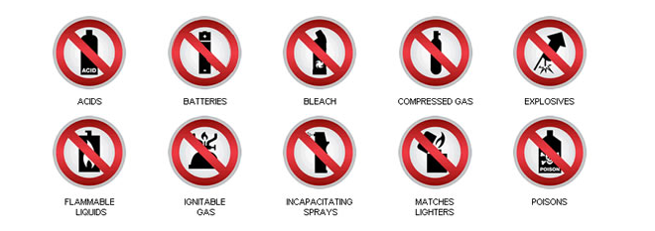

Passenger baggage must not contain any articles or substances that may present a danger during transport including those shown above. Some exceptions may apply. Please check the hazardous materials conditions with the airline you will be flying.

To avoid harassment at any international airport in the country, try not to travel with the following; Cash in excess USD5, 000.00; Gift items worth NGN50,000.00, Smartphones are exempt; pharmaceutical products should not be carried in bulk, they should be doctor’s prescription only; Hard drugs; Sparkling wines, stout & beer; Live animals; Fresh/preserved foods, jewellery/precious metals; Guns, Firearms and Explosives and other sharp objects. If you are in doubt, please clarify before embarking on your journey as there is no ignorance before the law. You must also abide by Airline prohibitions.

3.4 **Before you depart for Abuja:** Ensure that your Terms of Reference (TOR) is approved. Your travel risk assessment is also approved by your line manager and the Global Security Manager(GSM). You must undertake the online Travel Safety and Security training.

Read and familiarise yourself with information contained in the welcome guide sent to you.

Make sure you have a mobile phone on you that work on a frequency of 900 – 1800MHz in Nigeria and your roaming is updated.

It is important that you carry with you a copy of the following documents and always ensure that they are secured while you are in transit;

* Passport and Next of Kin details
* Invitation letter/ details of WaterAid in Nigeria key contact person
* Details of medical insurance and medical evacuation insurance
* Details of relevant health condition, diseases and medication.

# It is also advisable to scan /email copies of data and visa pages of your passport and vaccination card (if necessary) to yourself. This will be very useful in the worst case scenario that these documents are lost.

*3.5* **Procedures on Arrival at the Airport:**

On arrival, Immigration officials will separate Internationals from Nigerian Nationals. You will be handed an immigration card to fill in your details. Ensure that you fill this card which sometimes is given to you on the flight prior to landing.

Make sure you have all your travel documents in a readily accessible but secure place. This include your checked baggage stubs.

Once you are done with filling the card you will proceed to immigration booth where your passport will be stamped.

Luggage is collected after passing through immigration using a conveyor belt similar to what you would experience in most airports in West Africa. A fee of N500 is charged to rent a luggage trolley.

It is not unlikely that trolley operators will offer to assist with a trolley and with picking your luggage. You should expect that these persons will seek for a payment once they have assisted you. If you are able to manage your luggage yourself it is better to do so, --The airport is small and you will not have to carry your luggage far before you reach the driver assigned to pick you up.

Between the conveyor belt for luggage and the exit, you will find customs and excise officials waiting to conduct random checks on arriving passengers. They may ask you to open your bags for inspection and may ask you questions about the contents and purpose of your travel. Politely responding to their questions and emphasizing you are visiting Nigeria at the invitation or to do work for an international NGO would normally be useful to reduce the customs interrogations.

Occasionally, customs officials may try to solicit bribes such as asking for gifts etc. A polite refusal is normally enough to dissuade them

3.6 **Getting there**

Airport security personnel will not usually permit the drivers to enter the airport arrival lounge, it is therefore necessary to leave the airport lounge to locate the driver assigned to pick you.

The driver assigned to pick you should be waiting as you exit the airport terminal building and can be identified with a WANG sign he will be holding up for clear view.

There will be many other cars and drivers there to pick up arriving guests. It is important to ask the driver for his name and the name of the person he is there to collect to verify that he is the WANG driver. Ask for ID if you are uncertain.

The driver will assist you with your luggage, escort you to the car and drive you to the hotel.

To be double sure you can ask the driver to call the WANG SLM so you speak with him for further confirmation

**4. 0 ACCOMMODATION**

WaterAid Nigeria has a range of hotels that have gone through a prequalification process

and are certified safe and secured for staff and visitors accommodation. You will be accommodated in one of the hotels in the course of your visit to WaterAid Nigeria

4.1 Accommodation has therefore been reserved for you @ Sheer Luxury Apartments & Suites. It offers 70 tastefully furnished apartments and suites in a peaceful and secure environment suitable for business and private travelers

Sheer Luxury Apartments and Suites

NO.35 Umaru Dikko, off Mike Akhigbe Way,

Jabi, Abuja.

Tele:  +234 909 887 5290

          +234 809 111 5609

[frontoffice@sheerluxuryabuja.com](mailto:frontoffice@sheerluxuryabuja.com)

[www.sheerluxuryabuja.com](http://www.sheerluxuryabuja.com)

**4.2 Hotel Services / Picture of Hotel**

The hotel has the following facilities and services:

* 24-hour room service
* 24-hour laundry service
* Restaurant and bar services
* Gym & swimming pool facilities
* Breakfast available
* Equipment kitchenette
* Sterilizing unit
* Microwave
* Refrigerators
* High speed internet
* Well laid bathrooms with hair dryers
* Multi Satellite TV Channels on LED Screen

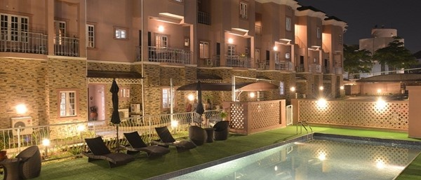

**Front side view of Sheer Luxury Apartments & Suites Abuja**

**5.0 Safety & Security**

Before conducting any International travel, all WaterAid staff are required to complete the Online “travel Safety and security Course”- please ensure this has been done.

**5:1 The overall security level for Nigeria is: High.**

**5:1:2 Political:** The Polity had stabilized after the 2015 General elections until with the approaching 2019 General Elections. The polity is gradually beginning to be unstable with activities of politicians and Political Parties both at State and the Federal levels. The Governments actions and inactions against perceived opposition elements has continue to heat up the political environment. Political parties have concluded party primary elections with attendant crisis and violence that trailed its conduct, now we are in the phase for political campaigns for the presidential/National Assembly and Governorship and State Assembly elections. Campaigns is just starting so there are no red flags yet. We are monitoring the political situation carefully and will be able to pick up triggers that might led to crisis and put in mitigation measures as appropriate. Specifically, we are developing an Election Contingency /Scenario plan to provide a strategic guide and response to the entire election period.

**5:1:3 Crime:** Crime risk rating for Nigeria is high. The country experiences severely high levels of both violent and petty street crime, perpetrated by individuals and gangs. Violent crime occurs in various forms, including murder, armed robbery, assault, burglaries, sexual assault, and carjacking. Some of this basic tips are useful to minimise your exposure to falling victim of crime while in Nigeria:

1. Visitors are urged to be sensible with their possessions, not to leave valuables lying around.
2. Avoid openly displaying / carrying expensive cameras, communications, video equipment and such. This draws attention and exposes you unnecessarily
3. It is also not advisable to go around (especially late at night) on your own.
4. Avoid developing routines; always ensure someone knows where you are at all times.
5. Avoid using ATM that are in isolated locations of the city, do not ask anyone for help at any ATM.
6. Do not also enter into any financial transaction with anyone without the express guidance of WANG staff.
7. Avoid specific locations of the city that are prone to crime. The Security and Logistics Manager will share with you, dos and don’ts during the arrival briefing

**5:1:4 Terrorism:** There is a high risk of terrorism in Nigeria, stemming from a number of criminal individuals, armed groups and gangs. The risk is considered high to extreme in a number of north eastern states, Borno, Adamawa and Yobe States. Activities of Boko Haram which poses the primary terrorism threat within Nigeria has continued to impact on the security situation in the North East. The risk of terrorism attacks outside the North East and Abuja still exist as an attack on Abuja as Nigeria Capital will send the message that terrorist group Boko Haram has not been defeated as claimed by the Nigeria Government. Care and caution has to be exercised to avoid being at the wrong or even right place at a wrong time

**5:1:5 Kidnapping:** The risk of kidnapping in Nigeria is rated as high and the country is one of the world's pre-eminent kidnapping hotspots. The risk of kidnapping can be minimised if the following is observed:

1. Maintain a low profile,
2. Keep your itinerary on a need to know basis and be conscious of activities and environment around you at all times.
3. Profile any environment you find yourself within a short time, you will minimise your exposure to such risk some of which may be opportunistic
4. Do not attempt any movement outside your hotel without guidance from the Security and Logistics Manager.
5. Do not over expose your self
6. Do not be adventurous

**5.1.6** **Political/Civil Unrest & Demonstrations:** Abuja do experience a lot of demonstrations or

Protests from groups that may be aggrieved by Government action or perceived inaction on certain issues. Abuja is targeted for some of these protests because it is the seat of Government and there is a high tendency to be heard. Currently the Islamic Movement of Nigeria(IMN) have been carrying out public protests demanding the release of their detained leader. Other protest some time are sporadic and can happen at any time. We are constantly monitoring the situation in collaboration with other security stakeholders and will be able to provide real time information on any protests happening in Abuja while you are here. You will be properly guided while you are in Abuja concerning any public protest or demonstrations.

**5:1:7 Conduct of Security Personnel**: Nigerian security personnel attach a lot of importance to maintaining security around the city of Abuja. You are likely to be subjected to searches before being allowed into public and private commercial buildings. You are also unlikely to be allowed to randomly take pictures around the town, especially of public areas and structures.

WANG Country Programme has taken every precaution to ensure that the risks associated with the security challenges in the country are kept to a minimum and appropriate procedures are in place to deal with any incidents. These guidelines are intended to ensure that both staff and visitors have the necessary information to minimize the risk to their personal safety

***5.2.*****On Arrival Verbal Security Briefing**

You will be provided a security briefing at the WaterAid Nigeria office by the Security and Logistics Manager (SLM*)*

Name: Jonathan Kuusu

Mobile No: +234 903 230 0332

Mail: Jonathankuusu@wateraid.org

**6.0 Nice to Know**

**6.1 GETTING AROUND IN ABUJA**

The most common means of transport within Abuja is by taxi or car hires. The taxis within Abuja are coloured green with white stripes and are easily recognizable. There are also privately owned car hire services which can be found within the town. It is advisable to book these through the hotel. They would normally cost more than the regular taxis but are usually safer.

Though there are several private taxis (not painted in the approved green and white colours), you are strongly advised not to use these as they are not registered. Also, you are strongly advised against the use of motorcycle taxis during your stay in Nigeria – not even for the **‘Okada’** experience☺. Please note that there are no meters in taxis so you should always negotiate with the driver before getting in. Typically, trips within the city will cost between N 300 and N 500 and may be more depending on the distance. We will arrange a dedicated vehicle for your movement while in Abuja

**6.2 CURRENCY AND BANKING**

The Nigeria currency comprises of the Naira and Kobo. Visitors may be asked (although it seldom happens) to declare their foreign currency at points of entry. International credit cards may be used in big hotels; care has to be exercised as to their usage as one can fall victim of credit card fraud easily. There are several Bureau de Change outlets where foreign currencies could be changed for local currency. It is however easier to change pounds sterling, US dollars, and Euros than any other currency.

Please note also that currency dealers have a preference for exchanging larger foreign currency denominations but will exchange notes of any value. For smaller denominations, they may charge a higher rate of exchange. Prevailing exchange rates at the time of your visit for the major currencies: USD, GBP & EUR will be communicated to you before departing for Nigeria. The Security and Logistics Manager will support to change money for you if required. Currently the exchange rates are as follows: GBP1=NGN472.43; USD 1= NGN362.82 & EUR1= NGN417

**6.3 FEEDING**

Most of the hotels used by WaterAid Nigeria have provision for complimentary breakfast. Per diems will be provided to visitors in line with prevailing policy on per diems. For all UK staff and others specified, no per diems will be provided for you as you are required to consume actual.

**7.0 Key Contacts**

Country code for Nigeria is +234

WA Nigeria Country Programme Office

Landline: +234 810 219 9951

|  |  |  |
| --- | --- | --- |
| Name | Job Title | Phone Contact |
| ChiChi Okoye | Country Director | ⁺234 708 869 8168 |
| Mamuda Salisu | Head Fin & IT | ₊234 903 780 8430 |
| Ukeme Essien | Coord. Planning & Strategy | ₊234 802 501 4853 |
| Manasseh Igyuh | Head People & Org. Dev. | ₊234 812 563 4291 |
| Oumar Ndiaye | Head of Strategic Partnerships | +234 906 265 4359 |
| Jonathan Kuusu | Security & Logistics Manager | +234 903 780 8422 |
|  |  |  |
|  | Police Emergency Numbers  Special Anti-Robbery Squad, FCT  Anti-Robbery Squad ‘B’ Control | +234 8033300952  +234 8032003913  +234-9-5238711  +234-9-5238722 |
|  | Fire Brigade  Abuja Headquarters  Wuse Zone 3 Service Station | +234-9-2341299  +234-9-5232465  +234 803 200 3557, 112 |
|  | Federal Road Safety Corps of Nigeria | +23470022553772  or +234 8077690362 (SMS Only) |
|  | UK 24 hr Call & Txt Handling Services | Call +44 1489568330  Text: +44 7860035318 (SMS Only) |
|  | Tabitha Medical Centre  40 Mike Akhigbe Way, Jabi | +234 704 682 2192 |
|  |  |  |

Once again Welcome to Abuja, Nigeria!